**LINK to GitHub:** https://github.com/GenericUser2025/csd-340

**HTML Validator - Error:**

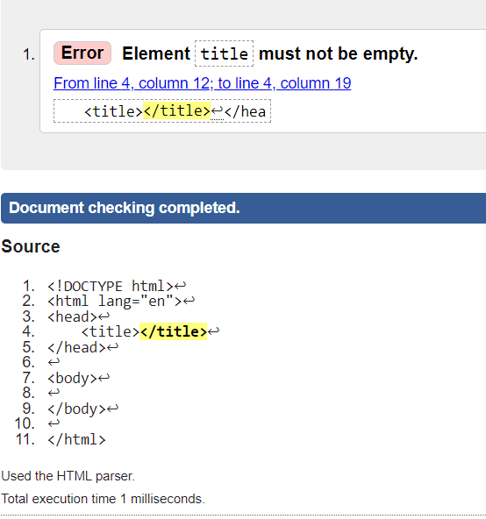

**HTML Validator - Title Correction with No Errors:**

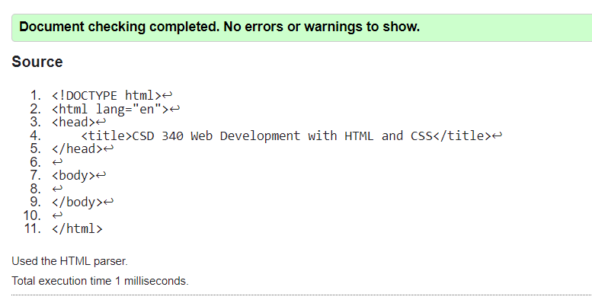

SEE NEXT PAGE!

**HTML Validator - Body Correction with No Errors:**

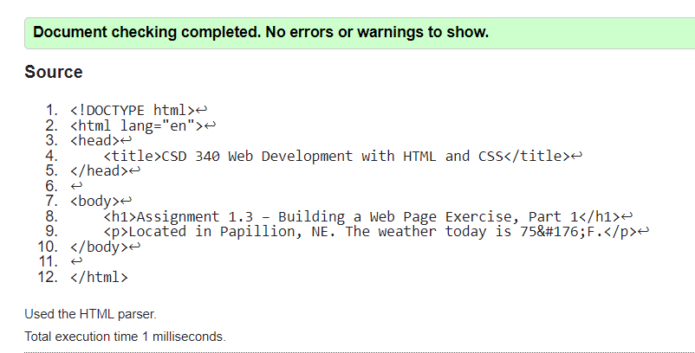

**Screenshot of Successful Webpage from Local File: (Google Chrome)**

